
Koneru Lakshmaiah Education Foundation
(Deemed to be University estd. u/s. 3 of the UGC Act, 1956)
Off-Campus: Bachupally-Gandimaisamma Road, Bowrampet, Hyderabad, Telangana - 500 043. Phone No: 7815926816, www.klh.edu.in

STUDENT CASE STUDY EXECUTION REPORT
Department | FED
Subject | DSA-2
Academic Year | 1-111 Semester | 2025-26
Faculty Name | LAHARI
Student Name | S.VENNELA
Roll Number | 2520080018
Branch | AI&DS
Course Outcome | 3
Case Study Topic : JobMatch Recruiter-Candidate Network using BFS/DFS and Minimum Spanning Tree
Work Done Summary:
In this case study, we modelled the JobMatch professional network as a weighted undirected graph where nodes represent recruiters and candidates, and edges represent connection strength (based on shared skills, mutual connections, or referral score, weighted 1–10). We applied BFS to find the shortest connection path (fewest hops) between a recruiter and a candidate, simulating the 'degrees of separation' feature. DFS was used to detect all connected components — identifying isolated candidates not reachable by any recruiter. Kruskal's and Prim's algorithms were then applied to construct the Minimum Spanning Tree (MST) of the network, which represents the minimum-cost set of connections to keep all nodes reachable — useful for infrastructure design of the platform's recommendation graph.

Implementation Details:
1. Represented JobMatch network as adjacency list with 8 nodes (3 recruiters R1-R3, 5 candidates C1-C5).
2. Added weighted edges: R1-C1(4), R1-C2(2), C1-C3(5), C2-C3(1), R2-C3(3), R2-C4(6), C4-C5(2), R3-C5(7).
3. Applied BFS from R1: found shortest path to C4 = R1 -> C2 -> C3 -> R2 -> C4 (4 hops).
4. Applied DFS from R1: identified all nodes reachable from R1 (all 8 nodes - fully connected graph).
5. Simulated disconnected node C6 (no edges); DFS reported C6 as isolated component.
6. Ran Kruskal's algorithm: sorted edges by weight, applied Union-Find to build MST.
7. Ran Prim's algorithm: starting from R1, greedily added minimum weight edges.
8. Both algorithms produced same MST with total weight = 18.
9. Compared BFS vs DFS traversal order and MST algorithms for network connectivity use case

Result: Screenshots / Output
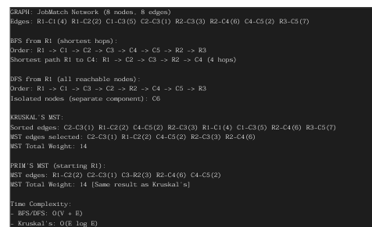
BFS successfully found the shortest connection path (fewest hops) between recruiter R1 and candidate C4. DFS identified the isolated candidate C6 not connected to any recruiter. Both Kruskal's and Prim's algorithms produced the same MST with total weight 14, representing the minimum-cost network backbone for the JobMatch platform

Time Complexity:-

- BFS/DFS: O(V + E)
- Kruskal's MST: O(E log E)
- Prim's MST (min-heap): O(E log V) BFS is ideal for 'degrees of separation' feature; MST minimises infrastructure cost of the network.

GETHUB LINK : https://github.com/SVennela07/dsa-2-case-study

Student Signature Faculty Signature

